Q) Perform Linear Regression on the following dataset in Python/R for predicting the salary of the person depending on his/her years of experience.
import numpy as np
import pandas as pd
import matplotlib.pyplot as plt
from sklearn.linear_model import LinearRegression
from sklearn.metrics import r2_score, mean_squared_error
# Dataset
data = {
"Years_Experience": [1, 2, 3, 4, 5, 6, 7, 8],
"Salary": [30000, 35000, 40000, 45000, 50000, 55000, 60000, 65000]
}
df = pd.DataFrame(data)
# Independent and Dependent variables
X = df[["Years_Experience"]]
y = df["Salary"]
# Create model
model = LinearRegression()
model.fit(X, y)
# Model parameters
intercept = model.intercept_
slope = model.coef_[0]
print("Simple Linear Regression Model")
print("-------------------------------")
print("Intercept (β0):", intercept)
print("Slope (β1):", slope)
print("\nRegression Equation:")
print(f"Salary = {intercept:.2f} + {slope:.2f} * Years_Experience")
# Prediction
y_pred = model.predict(X)
# Performance metrics
r2 = r2_score(y, y_pred)
mse = mean_squared_error(y, y_pred)
rmse = np.sqrt(mse)
print("\nModel Performance")
print("-------------------------------")
print("R-squared (R2):", r2)
print("Mean Squared Error (MSE):", mse)
print("Root Mean Squared Error (RMSE):", rmse)
# Visualization
plt.scatter(X, y, label="Actual Data")
plt.plot(X, y_pred, label="Regression Line")
plt.xlabel("Years of Experience")
plt.ylabel("Salary")
plt.title("Linear Regression: Salary vs Experience")
plt.legend()
plt.show()
Q1) B)
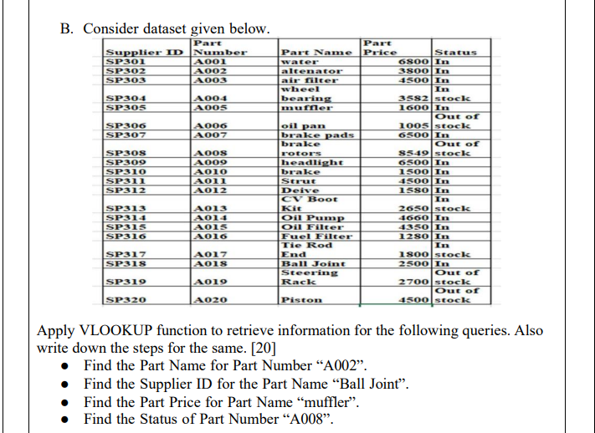

Find the Part Name for Part Number “A002”. =VLOOKUP("A002",B2:E21,2,FALSE)
Find the Supplier ID for the Part Name “Ball Joint”. =INDEX(A2:A21,MATCH("Ball Joint",C2:C21,0))
Find the Part Price for Part Name “muffler”. =VLOOKUP("muffler",C2:E21,2,FALSE)
Find the Status of Part Number “A008” =VLOOKUP("A008",B2:E21,4,FALSE)

Q] A Consider a scenario where you have test scores from a sample of students and you want to compare the mean of these scores with hypothesized population mean.
Student Score = [72, 88, 64, 74, 67, 79, 85, 75, 89,77]
Apply One Sampled T-Test using Python/R for above problem. Assume hypothesized mean as 70. Formulate Null and Alternative Hypothesis for a given problem. Interpret the results and draw the conclusion.

import numpy as np
from scipy import stats
# Student scores
scores = [72, 88, 64, 74, 67, 79, 85, 75, 89, 77]
# Hypothesized population mean
population_mean = 70
# Perform One Sample T-Test
t_statistic, p_value = stats.ttest_1samp(scores, population_mean)
print("T-Statistic:", t_statistic)
print("P-Value:", p_value)
alpha = 0.05
if p_value < alpha:
print("Reject Null Hypothesis")
else:
print("Fail to Reject Null Hypothesis")
print("Sample Mean:", np.mean(scores))

Q] Apply Feature Scaling technique like standardization and normalization using Python/R to Boston Housing dataset.
import pandas as pd
import numpy as np
from sklearn.preprocessing import StandardScaler, MinMaxScaler
# Load Boston Housing dataset manually
data_url = "http://lib.stat.cmu.edu/datasets/boston"
raw_df = pd.read_csv(data_url, sep="\s+", skiprows=22, header=None)
data = np.hstack([raw_df.values[::2, :], raw_df.values[1::2, :2]])
target = raw_df.values[1::2, 2]
# Column names
columns = ["CRIM","ZN","INDUS","CHAS","NOX","RM","AGE","DIS","RAD","TAX","PTRATIO","B","LSTAT"]
df = pd.DataFrame(data, columns=columns)
print("Original Data Sample:")
print(df.head())
# Standardization
standard_scaler = StandardScaler()
standardized_data = standard_scaler.fit_transform(df)
print("\nStandardized Data Sample:")
print(standardized_data[:5])
# Normalization
minmax_scaler = MinMaxScaler()
normalized_data = minmax_scaler.fit_transform(df)
print("\nNormalized Data Sample:")
print(normalized_data[:5])

QA) Perform Logistic Regression on the Iris dataset using Python/R to predict binary outcome. Evaluate model’s performance using classification metrics
code :
import pandas as pd
import numpy as np
from sklearn.datasets import load_iris
from sklearn.model_selection import train_test_split
from sklearn.linear_model import LogisticRegression
from sklearn.metrics import accuracy_score, precision_score, recall_score, classification_report
# Load Iris dataset
iris = load_iris()
X = iris.data
y = iris.target
# Convert to binary classification
# 1 = Iris-Virginica, 0 = Others
y = (y == 2).astype(int)
# Split dataset
X_train, X_test, y_train, y_test = train_test_split(
X, y, test_size=0.2, random_state=42
)
# Train Logistic Regression model
model = LogisticRegression(max_iter=200)
model.fit(X_train, y_train)
# Prediction
y_pred = model.predict(X_test)
# Evaluation Metrics
print("Logistic Regression Performance")
print("--------------------------------")
print("Accuracy:", accuracy_score(y_test, y_pred))
print("Precision:", precision_score(y_test, y_pred))
print("Recall:", recall_score(y_test, y_pred))
print("\nClassification Report")
print(classification_report(y_test, y_pred))

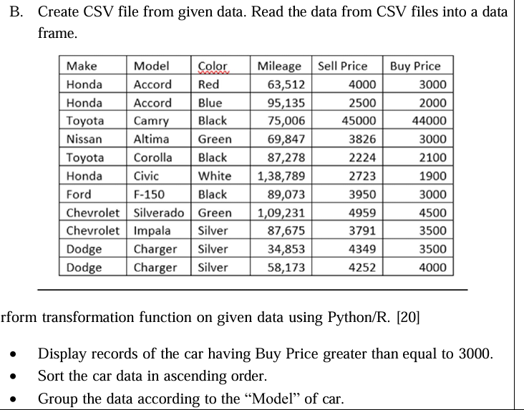

import pandas as pd
# Read CSV file
df = pd.read_csv("Data.csv")
print("Original Car Data:")
print(df)
# 1 Display cars with Sell Price > 4000
filtered_df = df[df["Sell Price"] > 4000]
print("\nCars with Sell Price greater than 4000:")
print(filtered_df)
# 2 Sort car data in ascending order of Sell Price
sorted_df = df.sort_values(by="Sell Price", ascending=True)
print("\nCar Data Sorted in Ascending Order:")
print(sorted_df)
# 3 Group data according to Make
grouped_df = df.groupby("Make")["Sell Price"].mean()
print("\nAverage Sell Price by Car Make:")
print(grouped_df)

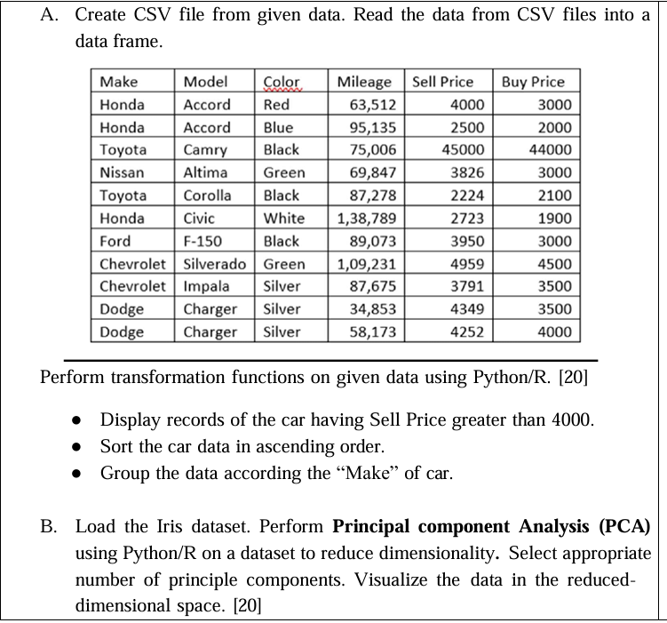
A code:
import pandas as pd

# Step 1: Create dataset
data = {
"Make": ["Honda","Honda","Toyota","Nissan","Toyota","Honda","Ford","Chevrolet","Chevrolet","Dodge","Dodge"],
"Model": ["Accord","Accord","Camry","Altima","Corolla","Civic","F-150","Silverado","Impala","Charger","Charger"],
"Color": ["Red","Blue","Black","Green","Black","White","Black","Green","Silver","Silver","Silver"],
"Mileage": [63512,95135,75006,69847,87278,138789,89073,109231,87675,34853,58173],
"Sell Price": [4000,2500,45000,3826,2224,2723,3950,4959,3791,4349,4252],
"Buy Price": [3000,2000,44000,3000,2100,1900,3000,4500,3500,3500,4000]
}

# Step 2: Convert to DataFrame
df = pd.DataFrame(data)
# Step 3: Save as CSV
df.to_csv("cars.csv", index=False)
# Step 4: Read CSV file
df = pd.read_csv("Data.csv")
print("Original Dataset:")
print(df)
# -------------------------------------------------
# Display records where Sell Price > 4000
print("\nCars with Sell Price greater than 4000:")
filtered = df[df["Sell Price"] > 4000]
print(filtered)
# -------------------------------------------------
# Sort the car data in ascending order by Sell Price
print("\nSorted Data (Ascending Sell Price):")
sorted_data = df.sort_values(by="Sell Price", ascending=True)
print(sorted_data)
# -------------------------------------------------
# Group the data according to Make
print("\nGrouped Data by Make:")
grouped = df.groupby("Make")
print(grouped.size())

B) Perform PCA on a dataset to reduce dimensionality. Evaluate the explained variance and select the appropriate number of principal components. Visualize the data in the reduced-dimensional space.

import numpy as np
import pandas as pd
import matplotlib.pyplot as plt
from sklearn.preprocessing import StandardScaler
from sklearn.decomposition import PCA
from sklearn.datasets import load_iris
iris = load_iris()
X = iris.data
y = iris.target
df = pd.DataFrame(X, columns=iris.feature_names)
print("Original Data Shape:", X.shape)
print(df.head())
scaler = StandardScaler()
X_scaled = scaler.fit_transform(X)
pca = PCA()
X_pca = pca.fit_transform(X_scaled)
explained_variance = pca.explained_variance_ratio_
cumulative_variance = np.cumsum(explained_variance)
print("\nExplained Variance Ratio:")
print(explained_variance)
print("\nCumulative Explained Variance:")
print(cumulative_variance)
n_components = np.argmax(cumulative_variance >= 0.95) + 1
print("\nNumber of components to retain 95% variance:", n_components)
pca_final = PCA(n_components=n_components)
X_reduced = pca_final.fit_transform(X_scaled)
print("Reduced Data Shape:", X_reduced.shape)
plt.figure(figsize=(8,5))
plt.plot(range(1, len(explained_variance)+1), explained_variance, marker='o')
plt.title("Scree Plot")
plt.xlabel("Principal Component")
plt.ylabel("Explained Variance Ratio")
plt.grid()
plt.show()
plt.figure(figsize=(8,5))
plt.plot(range(1, len(cumulative_variance)+1), cumulative_variance, marker='o')
plt.axhline(y=0.95, color='r', linestyle='--')
plt.title("Cumulative Explained Variance")
plt.xlabel("Number of Components")
plt.ylabel("Cumulative Variance")
plt.grid()
plt.show()
if n_components >= 2:
plt.figure(figsize=(8,6))
plt.scatter(X_reduced[:, 0], X_reduced[:, 1], c=y)
plt.xlabel("Principal Component 1")
plt.ylabel("Principal Component 2")
plt.title("PCA Reduced Data (2D Visualization)")
plt.colorbar(label="Target Class")
plt.grid()
plt.show()

Q) A. Perform Linear Regression on the Iris dataset of R/Python for predicting petal.width on petal.length.

import pandas as pd
import numpy as np
import matplotlib.pyplot as plt
from sklearn.linear_model import LinearRegression
from sklearn.datasets import load_iris
from sklearn.model_selection import train_test_split
# Load Iris Dataset
iris = load_iris()
# Create DataFrame
df = pd.DataFrame(iris.data, columns=iris.feature_names)
# Select required variables
X = df[['petal length (cm)']] # Independent variable
y = df['petal width (cm)'] # Dependent variable
# Split dataset into training and testing
X_train, X_test, y_train, y_test = train_test_split(X, y, test_size=0.2, random_state=42)
# Create Linear Regression model
model = LinearRegression()
# Train the model
model.fit(X_train, y_train)
# Predict values
y_pred = model.predict(X_test)
# Display equation
print("Intercept:", model.intercept_)
print("Coefficient:", model.coef_)
# Plot regression line
plt.scatter(X_test, y_test)
plt.plot(X_test, y_pred)
plt.xlabel("Petal Length (cm)")
plt.ylabel("Petal Width (cm)")
plt.title("Linear Regression: Petal Width vs Petal Length")
plt.show()

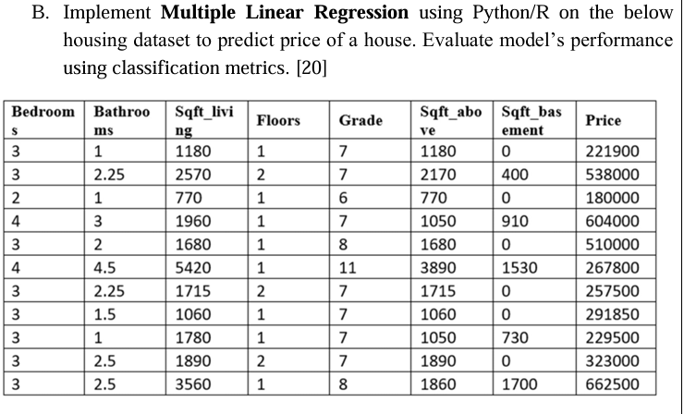
import numpy as np
import pandas as pd
import matplotlib.pyplot as plt
from sklearn.linear_model import LinearRegression
from sklearn.metrics import r2_score, mean_squared_error
# Housing dataset from the question
data = {
"Bedrooms": [3,3,2,4,3,4,3,3,3,3,3],
"Bathrooms": [1,2.25,1,3,2,4.5,2.25,1.5,1,2.5,2.5],
"Sqft_living": [1180,2570,770,1960,1680,5420,1715,1060,1780,1890,3560],
"Floors": [1,2,1,1,1,1,2,1,1,2,1],
"Grade": [7,7,6,7,8,11,7,7,7,7,8],
"Sqft_above": [1180,2170,770,1050,1680,3890,1715,1060,1050,1890,1860],
"Sqft_basement": [0,400,0,910,0,1530,0,0,730,0,1700],
"Price": [221900,538000,180000,604000,510000,267800,257500,291850,229500,323000,662500]
}
df = pd.DataFrame(data)
# Independent variables
X = df.drop("Price", axis=1)
# Dependent variable
y = df["Price"]
# Create model
model = LinearRegression()
model.fit(X, y)
# Predictions
y_pred = model.predict(X)
# Model parameters
intercept = model.intercept_
coefficients = model.coef_
print("MULTIPLE LINEAR REGRESSION MODEL FOR HOUSE PRICE")
print(f"\nIntercept (β0): {intercept:.2f}")
for i, col in enumerate(X.columns):
print(f"Coefficient for {col} (β{i+1}): {coefficients[i]:.2f}")
# Regression equation
print("\nRegression Equation:")
equation = f"Price = {intercept:.2f}"
for i, col in enumerate(X.columns):
equation += f" + ({coefficients[i]:.2f} * {col})"
print(equation)
# Performance metrics
r2 = r2_score(y, y_pred)
mse = mean_squared_error(y, y_pred)
rmse = np.sqrt(mse)
print("\nMODEL PERFORMANCE")
print(f"R-squared (R²): {r2:.4f}")
print(f"Mean Squared Error (MSE): {mse:.4f}")
print(f"Root Mean Squared Error (RMSE): {rmse:.4f}")
# Plot Actual vs Predicted
plt.scatter(y, y_pred)
plt.plot([y.min(), y.max()], [y.min(), y.max()])
plt.xlabel("Actual Price")
plt.ylabel("Predicted Price")
plt.title("Actual vs Predicted House Price")
plt.grid(True)
plt.show()

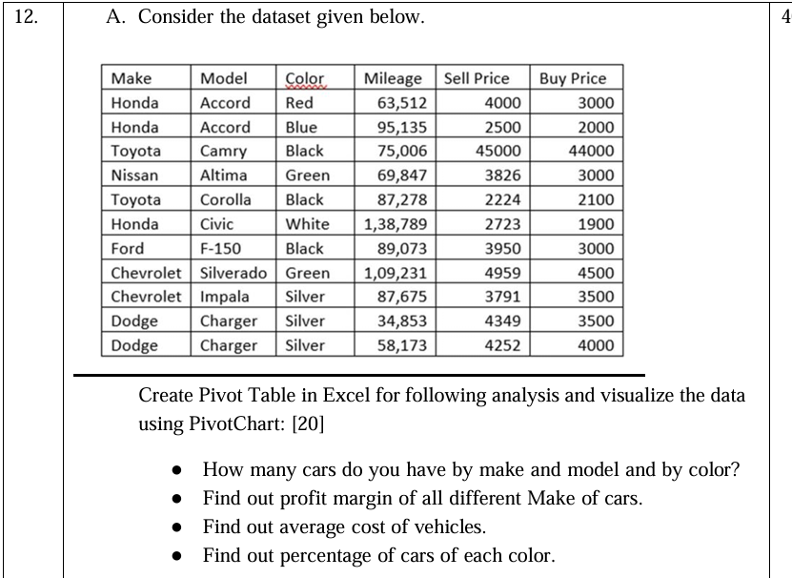1. Number of Cars by Make, Model and Color
Pivot Settings
- Rows: Make → Model
- Columns: Color
- Values: Count of Make
2. Profit Margin of Each Make
First add a new column in Excel:
Profit = Sell Price − Buy Price
Example formula:
=E2-F2
Then create Pivot Table:
- Rows: Make
- Values: Sum of Profit

3. Average Cost of Vehicles
Assume Sell Price = Cost of vehicle
Pivot Table settings:
- Rows: Make
- Values: Average of Sell Price

4. Percentage of Cars by Color
Pivot settings:
- Rows: Color
- Values: Count of Color
- Right-click value → Show Values As → % of Grand Total

Q] The employee’s aptitude and job proficiency score is as follows. Perform Chi-Square Test to study correlation between aptitude and job proficiency of employee. Formulate Null and Alternative Hypothesis for a given problem. Interprete results and draw conclusions based on test outcome.

import numpy as np
from scipy.stats import chi2_contingency
# Contingency table
data = np.array([[30, 20],
[25, 35]])
# Perform Chi-Square Test
chi2, p, dof, expected = chi2_contingency(data)
print("Chi-square statistic:", chi2)
print("P-value:", p)
print("Degrees of freedom:", dof)
print("Expected frequencies:\n", expected)
alpha = 0.05
if p < alpha:
print("Reject Null Hypothesis")
else:
print("Fail to Reject Null Hypothesis")

Q] The company is accessing the difference in time to complete the task between two groups of employees. State the hypothesis and do the Two Sampled T-Test using Python/R for the given dataset.
Group-I: Experience(0-1 year)
Group-II: Experience(1-2 year)
Time taken by Group1: 85,95,100,80,90,97,104,95,88,92,94,99
Time taken by Group2: 83,85,96,92,100,104,94,95,88,90,93,94

import numpy as np
from scipy import stats
# Time taken by two groups
group1 = np.array([85,95,100,80,90,97,104,95,88,92,94,99])
group2 = np.array([83,85,96,92,100,104,94,95,88,90,93,94])
# Two Sample T-Test
t_stat, p_value = stats.ttest_ind(group1, group2)
print("T-statistic:", t_stat)
print("P-value:", p_value)
alpha = 0.05
if p_value < alpha:
print("Reject Null Hypothesis")
else:
print("Fail to Reject Null Hypothesis")

Q] Perform Multiple Linear Regression on the “Pima Indian Diabetes dataset” using Python/R.

Open Notepad and save the file with the name of diabetes.csv & Write the following Code
Pregnancies,Glucose,BloodPressure,SkinThickness,Insulin,BMI,DiabetesPedigreeFunction,Age,Outcome
2,120,70,25,90,28.5,0.45,28,0
4,150,80,30,130,32.1,0.62,45,1
1,95,60,20,85,24.3,0.30,22,0
3,140,75,28,120,31.0,0.55,38,1
5,160,85,32,150,34.2,0.70,50,1
0,100,65,22,88,26.0,0.25,24,0
6,170,90,35,180,36.5,0.80,55,1
2,110,68,24,95,27.5,0.40,30,0
4,155,82,31,140,33.0,0.65,47,1
1,105,66,23,92,26.8,0.35,26,0

Then open IDLE and write the code given below

import pandas as pd
from sklearn.model_selection import train_test_split
from sklearn.linear_model import LinearRegression
from sklearn.metrics import r2_score
# Load dataset
data = pd.read_csv("diabetes.csv")
# Independent variables
X = data.drop("Outcome", axis=1)
# Dependent variable
y = data["Outcome"]
# Train test split
X_train, X_test, y_train, y_test = train_test_split(X, y, test_size=0.2)
# Model
model = LinearRegression()
# Train model
model.fit(X_train, y_train)
# Predictions
y_pred = model.predict(X_test)
print("R2 Score:", r2_score(y_test, y_pred))

